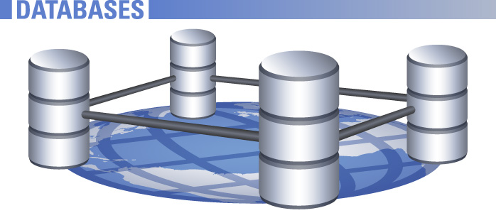

Advanced Databases Project

Requirements Specifications

The Document is broken into mainly 3 sections – Introduction, Overall Description and Specific Requirements.

Down below is the work done and review of the team members

|  |  |  |
| --- | --- | --- |
| **Student Number** | **Student name** | **Work done** |
| X13112406 | Navjot Singh Virk | Project Manager(Prepared & Finalized the requirement specification) |
| X13358421 | Usman Akhtar | Working well |
| X13358851 | Fasial Bashar | Working well (helped prepare the document) |
| X15006875 | Getulio | After repeated efforts not working well, haven’t read the notes yet and need to be guided as babies |
| X15008487 | Pedro | After repeated efforts not working well, slow and don’t take initiative |
| X12128201 | Naibin | Working fine, talk a lot on things except the project |

Table of Contents

**Advanced Databases** 2

Phone Shop System (PSS) 2

Introduction 2

Purpose of the Document 3

Scope and System Overview and the Structure of the system specified 3

Overall Description 3

Product Perspective 3

Product Functions 3

User Characteristics 4

Constraints, Assumptions and dependencies 4

Specific Requirements 4

External Interface Requirements 4

User Interface 4

Hardware Interface 4

Software Interfaces 4

Performance Requirement 4

Logical database 5

Functional Requirements 5

Non-Functional Requirements 5

# **Advanced Databases**

# Phone Shop System (PSS)

# Introduction

First of all starting with the Topic – Phone Shop (Online e-commerce Website Database) System. This document highlights and define all the requirements and specifications for this project in which we will Devise and populate database fulfilling a real business need and Build a website that will collect unstructured data in file format that will help us latter with creating data warehouse for easy access to the database data and this warehouse will be used to produce KPI dashboard in real time. In, the dashboard the user can see data, create or delete data.

## Purpose of the Document

The purpose of requirement and specifications document is to clearly define Phone Shop (Online ecommerce Website Database) System. The intended audience of the document are the owner, manager, sales assistants, of the Phone shop System and the end-users of PSS. Other intended audience include the development team such as the design team or other members of development organisation.

## Scope and System Overview and the Structure of the system specified

Phone Shop system is based on a large corporate ecommerce database that intends to sell Mobile phones online. The database will contain all data about employees (such as employee id, employee address, employee name, etc.) let’s take another major example about products and then we will only list few examples of the data contained in the database. Let’s list the data related to products (product id, product name, product price, product description, product image, product update data, product updateTime, product updateDate, product stock, etc.)

Now, since we have the basic idea what the database will look like let’s list only some more example like orders, suppliers, categories, users, options, outlets, transactions, payment details etc.

Since, the PSS is built on the database of ecommerce website its dashboard allows to adding, removing, editing data, search for different brand of mobile phones by the name for example. Users can register online to make an account and so that they can add products to cart to buy it later. Users will see lots of different product from different mobile companies. Which can help the users to make quick decision to buy from our online shop. The users will need to add their address and contact details, so the product could be delivered to them easily. The database can be update by the admins only, when products in stock.

# Overall Description

## Product Perspective

PSS is a transaction process system based on a website. PSS is responsible for receiving Membership id and Mobiles Requests from customers, verifying membership id, processing mobile requests and issuing transaction report to customers, while updating all related data files. The data files can also be accessed by the administrator for up-dating and editing and all other tasks and data related to ecommerce website as well explained in structure of the system above.

Product development cycle.

* The product will be designed from the requirements.
* A website and a database is created from this design.
* The product undergoes testing.
* The product will be released
* The product will be further tested.

## Product Functions

The main purpose of PSS package is to enable the client to record and update all related databases when a buying transaction takes place with one easy to use software application.

With this in mind the PSS should have the following functions and features:

* Should provide an easy to use Interface
* Should be able to access all database files individually in order to edit details etc.
* When a buying transaction takes place the database files should automatically update
* System should provide a functionality to print a customer transaction report

## User Characteristics

*There are two classes of users for the MRS package*

*Sales Assistant*

The sales Assistant will be utilising the PSS package a lot of time to check, products, orders, stocks

*Administrator*

The administrator will use the PSS to update and edit files, while also having access to full transaction reports, again with an appropriate interface the administrator will not have to be technically minded in order to use the system.

## Constraints, Assumptions and dependencies

The short time frame provided by the client could give rise to errors which will have to be corrected after the release of the product to the client.It is assumed the client is providing hardware suitable to run the application on. The correct implementation of the system will depend on the administrator updating the data as new data is supplied, failure to do so would result in the system not being utilised as it was intended.

# Specific Requirements

# External Interface Requirements

User Interface - The system will provide an easy and accessible Interface. Dashboard for the administrator to check reports and statistics and add, delete or edit the data in the database. And there will be four interfaces interacting with customers. Which are as follows Sign In or Log in, Account details, Search Mobile Phones, Check any Overdue Interface, Check out customers, generate bill, Add or update customer records.

Hardware Interface - End-Users will access the product remotely using computers. The system will run on a Website.

Software Interfaces - The Mobile store requires following on a server:

1. MySQL server receives the database query and processes it.
2. Website to interact with admin, customers and user.

## Performance Requirement

These days Performance is the desired feature of every system along with easy maintainability. PSS is desired to be quick it will access data from MySQL. Worlds one of the best databases and the interface will be Website which will be quick and simple to use and manage.

## Logical database

For the good and secure database shop need a perfectionist who can save and stored all useful information and details about the shop. For example MySQL, Ms- Access are the major program where shop can place the details about the stock. Customers always want theirs data safe and secure, so for the registered customer and who bought Mobiles their payment systems along with personal details need to be safely stored in systems databases.

# Functional Requirements

Must be Easy to use, registration and login, allow dashboard for admin and access data from a large corporate ecommerce stores database and be able to edit, add or delete data.

# Non-Functional Requirements

Functional requirements shows the needs in terms of performance, design constraints, how reliable the system is, availability of the system, the database requirements, and the maintainability of system (means how easy it is to maintain the system).

The End

Special Thanks to our teacher

Eamon